# **CTF Topic: Scanning Network**

# **Introduction**



Enumeration is the process of actively gathering detailed information about a target system or network. This step typically follows initial reconnaissance and is crucial for identifying potential vulnerabilities. The goal is to extract as much information as possible about the target to understand its structure and identify weak points that can be exploited.

# **Tools and requirements**

1. [shodan](https://www.shodan.io/)

# **Scenario**



Imagine yourself as a penetration tester, Your task is to find out the given IP Address details like: Open ports, location etc. IP address of 8.8.8.8.

# **Process**

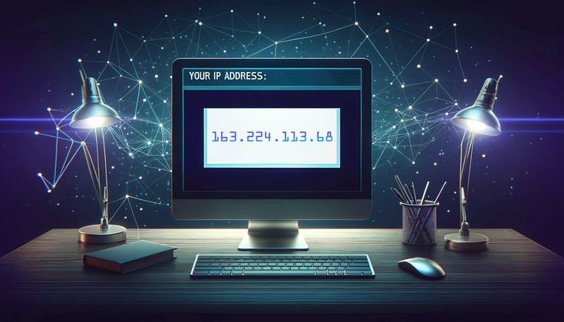

To begin you have to search the IP address by going on the given link.

<https://www.shodan.io/host/8.8.8.8>

# **Question**

**Flag 1: What are the opened ports?**

**Answer: 53,443**

**Flag Captured.**

**Flag 2: Which organization this ip belongs to?**

**Answer: Google LLC**

**Flag Captured.**

# **Hint**

